Application Form

Please complete ALL sections of this application form in order to be approved.

Fee to Participate in this mission – £150 +VAT

Which trade mission are you applying for?
Country
Date
Run by which Chamber

Company Name
Company Address
Postcode
Website
Sector / SIC Code
Annual turnover in the last financial year | £
No. of FTE Employees
Delegate Name (1)
Job Title
Email
Telephone
Delegate Name (2)
Job Title
Email
Telephone
Delegate Name (3)
Job Title
Email
Telephone

Does your business currently export goods or services internationally? | Yes ☐ | No ☐
Does your business already export goods or services to this market?* | Yes ☐ | No ☐
List your current export destinations (if applicable)
Current value of export sales
What is your experience in this market to date?

* Only SMEs who are new to export or new to market will be eligible to participate unless this has been on an ad-hoc basis for small amounts.

Provide a description of your business including your products or services.

Provide a note of any good practices in contributing to the application of the Scottish Government trade principles and your company’s application of fair work and inclusive employment practices (attachments / web links accepted).

What outcomes would you like to achieve by participating in this international trade mission?
eg. joint venture / appointment of a new distributor / B2B meetings
1.
2.
3.
4.
5.
6.

Is there any particular assistance you’re looking for?

Are you a member of a Chamber of Commerce? | Yes ☐ | No ☐
If Yes, which one(s)?
Have you attended a Chamber of Commerce trade mission before? | Yes ☐ | No ☐
If Yes, to which country(ies)?

Are you account managed by Scottish Enterprise (SDI)? | Yes ☐ | No ☐

A feedback form will be issued post-mission which must be completed in full which is mandatory upon completion of the trade mission. Please confirm this will be completed. | Yes ☐ | No ☐

Signature | Date

The Scottish Chambers of Commerce network is making the most of its unique position as a globally trusted and credible partner and we are working in partnership with the Scottish Government to boost Scotland’s exporting performance.
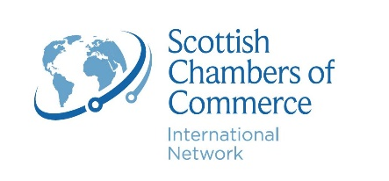

We are committed to the security of personal data. We take appropriate security measures to limit abuse of and unauthorised access to personal data. This ensures that only the necessary persons have access to your data, that access to the data is protected and that our security measures are regularly reviewed.

Your data will be shared with the Scottish Chambers of Commerce and Scottish Government as part of the International Trade Partnership contract and an independent end of programme evaluator, commissioned to understand what impacts have been achieved by the project and lessons to be learned from its delivery. Monitoring data and management information will be collected by the Scottish Chambers of Commerce following each mission from participating businesses including those listed on this application form and follow-up form.

The Scottish Chambers of Commerce may disclose any information as required by law or judicial order.

If selected for the trade mission, are you willing to participate in marketing & communications e.g. case studies? Yes or no’ | Yes ☐ | No ☐

Review our privacy policy here.

